**Assignment No. 16**

**Title:** Develop a Real time application like a smart home with following requirements: If anyone comes at door the camera module automatically captures his image send it to the email account of user or send notification to the user. Door will open only after user‘s approval. .

**Aim:** To understand the interface between web server, camera and Raspberry Pi for home automation

**Hardware Requirement**:

Raspberry Pi board with an SD card

**Software Requirement:** Raspbian O.S, Python.

**Theory:**

The problem can be divided into three sub parts:

* If anyone comes at door- we can detect if a person is entering at door by using IR sensor. Note: The code for the same is shared already.
* Camera module will automatically captures the image.

Note: The code for the same is shared already.

* Sending image on email for secure entry.
* **Setting up Server**

The smtplib module of Python is basically all you need to send simple emails, without any subject line or such additional information. But for real emails, you do need a subject line and lots of information—maybe even pictures and attachments. This is where Python’s email package comes in. Keep in mind that it’s not possible to send an email message using the email package alone. You need a combination of both **email** and **smtplib**.

Set up the SMTP server and log into your account.

• Create the MIMEMultipart message object and load it with appropriate headers for From, To, and Subject fields.

• Add your message body.

• Send the message using the SMTP server object.

The smtplib module defines an SMTP client session object that can be used to send mail to any Internet machine with an SMTP or ESMTP listener daemon. SMTP stands for Simple Mail Transfer Protocol.The smtplib modules is useful for communicating with mail servers to send mail.

**Sending mail is done with Python's smtplib using an SMTP server.**

Actual usage varies depending on complexity of the email and settings of the email server, the instructions here are based on sending email through Gmail.

**Download the smtplib from here:**

https://github.com/python/cpython/blob/2.7/Lib/smtplib.py

**Conclusion:** We have shown the steps of building the IoT application for home automation.

**Code:**

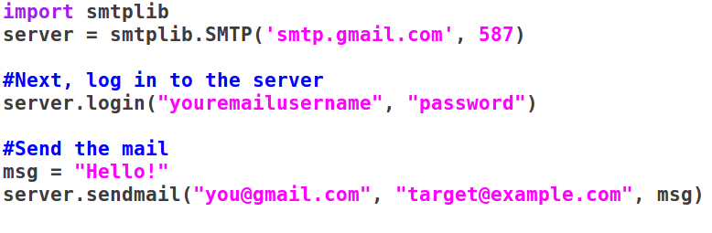

**Sending Attachments**

